**Portfolio Project**

MIS 540 Introduction to Business Intelligence

Colorado State University-Global Campus

Dr.  Orenthio Goodwin

March 13, 2022

Portfolio Project

Quality K-12 education provides effective career pathways for American families. Achieving economic mobility is a crucial aspect of public-school education. The fundamentals of K-12 education provide the workforce with the skills necessary to achieve employment and future financial independence. The key to improving education is targeted spending.

School funding is a controversial subject in many states. Schools in the United States are among the most inequitably funded of any in the industrialized world (**Learning Policy Institute, 2018).** Public schools are funded through local, state, and federal funds. Student outcomes have shown positive results with increased and targeted spending. While money alone may not be the answer, more equitable and adequate allocation of financial inputs to schooling provides a necessary underlying condition for improving the equity and adequacy of outcomes (Baker, 2017). K-12 schools receive funding from local, state, and federal governments. States provide the bulk of funding targeted at low-income students. The federal government is a secondary source of targeted funding for low-income students. States with the most money-targeted at low-income students are considered progressive states, while states with more money going to nonpoor students are considered regressive. The interaction between progressive and regressive states depends on local, state, and federal funding.

The dataset for this analysis is from the Institute of Education Studies, National Center for Education Statistics. The dataset focuses on urban education in America. The dataset includes US school districts receiving federal, state, and local revenues and the Census Bureau's Income and Poverty Estimates.

|  |
| --- |
| * State abbreviation |
| * Poverty rate |
| * Dissimilarity index based on district-level poverty rates |
| * Cost-adjusted per-pupil revenue (PPR), students in poverty |
| * Cost-adjusted PPR, students not in poverty |
| * Progressivity measure, cost-adjusted PPR from all sources |
| * Cost-adjusted PPR from the state, students in poverty |
| * Cost-adjusted PPR from the state, students not in poverty |
| * Progressivity measure, cost-adjusted PPR from state |
| * Cost-adjusted PPR from local sources, students in poverty |
| * Cost-adjusted PPR from local sources, students not in poverty |
| * Progressivity measure, cost-adjusted PPR from local sources |
| * Cost-adjusted PPR from federal sources, students in poverty |
| * Cost-adjusted PPR from federal sources, students not in poverty |
| * Progressivity measure, cost-adjusted PPR from federal sources |
| * Unadjusted per-pupil revenue (PPR), students in poverty |
| * Unadjusted PPR, students not in poverty |
| * Progressivity measure, unadjusted PPR from all sources |
| * Unadjusted PPR from the state, students in poverty |
| * Unadjusted PPR from the state, students not in poverty |
| * Progressivity measure, unadjusted PPR from state |
| * Unadjusted PPR from local sources, students in poverty |
| * Unadjusted PPR from local sources, students not in poverty |
| * Progressivity measure, unadjusted PPR from local sources |
| * Unadjusted PPR from federal sources, students in poverty |
| * Unadjusted PPR from federal sources, students not in poverty |
| * Progressivity measure, unadjusted PPR from federal sources |

Business Questions

1. Is the mean adjusted revenue difference per student at the state, local, and federal funding source equal?
2. Do school districts with higher poverty rates receive greater funding at any government level?
3. Is there a correlation between adjusted revenue per person poverty and funding at state, local, and government levels?
4. Is there a correlation between adjusted revenue per person nonpoverty and funding at state, local, and government levels?

Hypothesis

NULL HYPOTHESIS: The mean adjusted revenue difference per student at the state, local, and federal funding sources are equal.

ALTERNATIVE HYPOTHESIS: The mean adjusted revenue difference per student at the state, local, and federal funding sources are not equal.

NULL HYPOTHESIS: School districts with higher poverty rates receive greater funding at all government levels?

ALTERNATIVE HYPOTHESIS: School districts with higher poverty rates receive greater funding at all government levels?

NULL HYPOTHESIS: There is a correlation between adjusted revenue per person poverty and funding at state, local, and government levels?

ALTERNATIVE HYPOTHESIS: There is a correlation between adjusted revenue per person poverty and funding at state, local, and government levels?

NULL HYPOTHESIS: There is a correlation between adjusted revenue per person nonpoverty and funding at state, local, and government levels?

ALTERNATIVE HYPOTHESIS: There is a correlation between adjusted revenue per person nonpoverty and funding at state, local, and government levels?

Statistical Tests

Statistical tests will include mean, standard deviation, sum, minimum and maximum. This will represent the funding across all variables used to test the hypothesis. A Pearson correlation coefficient will show if a correlation exists between variables.

Visualization

A scatterplot matrix will depict if a linear relationship exists between variables. A scatterplot matrix provides a visual aid to understand the linear relationship. The relationship is linear or nonlinear, if linear negative or positive.

Variable Analysis

The first tests are the mean tests. The means test is used to compare adjusted revenue and unadjusted revenue for poverty, nonpoverty, and adjusted revenue difference. Adjusted revenue reflects costs associated to districts with higher costs compared to districts with lower costs. adjust districts’ funding amounts for differences in the costs they face, using a measure of the salaries of college graduates who are not teachers in the district’s labor market (**Learning Policy Institute, 2018).** The means test depicts the funding of schools from the state, local, and federal sources. The means procedures will depict if the median funding of K-12 schools is disproportionally distributed between state, local, and federal funding sources. The majority of funding comes from states followed by local school districts. A significant finding is the funding by local school districts. The median funding level from local school districts is -347.14. The 25th percentile is -663.81 and the 75th percentile is -99.97. The relationship in funding is inversely related compared to state and federal funding. This provides insight into how local districts fund schools and the difference between poverty and nonpoverty funding at the local level. At the local level, funding is often regressive; on average, districts with mostly nonpoor students tend to have more money to spend than districts that have many poor students (**Learning Policy Institute, 2018). This funding discrepancy is significant and consistent across many states.**

**Figure 1. Means Test Adjusted Revenue**

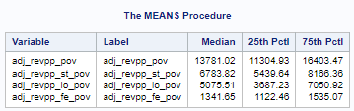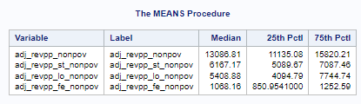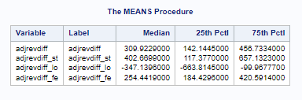

Notes. Screenshot from SAS.

Next, I found the mean for unadjusted revenue for the state, local, and federal funding. Here we see a similar pattern for local school districts. The median unadjusted revenue per person for local school district funding is -351.55. The 25th percentile is -659.79 and the 75th percentile is -98.24. This is similar to the adjusted revenue per person. There is a difference in state and federal funding when comparing state and federal funding median when comparing adjusted and unadjusted revenue differences. For states, the revenue difference between adjusted and unadjusted is $154.89. This is a 62% increase for adjusted revenue compared to unadjusted revenue. This suggests that states use a formula to target districts with higher costs. The federal difference between adjusted and unadjusted revenue per person is present at a smaller amount.

Figure 2. **Means Test Unadjusted Adjusted Revenue**

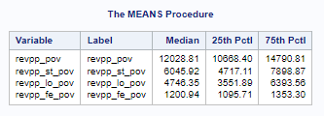

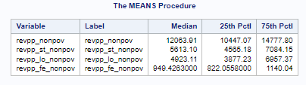

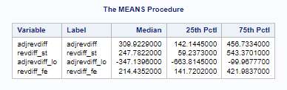

**Note. Screenshot from SAS.**

I used reg proc to test model fit for several scenarios to predict funding on an adjusted and nonadjusted basis. It is important to check the diagnostic plots to assess the quality of fit for the model. The plots will help evaluate the fit of the model, determine whether the data satisfies expectations about the dataset, and identify outliers and high-leverage points. I tested the following models:

* Poverty rate to Adjusted Revenue Per Person State – Poverty, Adjusted Revenue Per Person local – Poverty, and Adjusted Revenue Per Person Federal – Poverty.
* Poverty rate to Unadjusted Revenue Per Person State – Poverty, Unadjusted Revenue Per Person Local – Poverty, and Unadjusted Revenue Per Person Federal – Poverty.

I am presenting only the Poverty Rate - Adjusted Revenue model fit test figures. The models were similar in their outcome.

Figure 3. Fit Diagnostics Poverty Rate - Adjusted Revenue

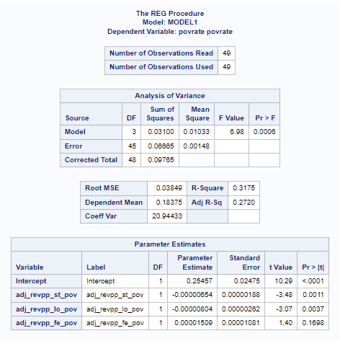

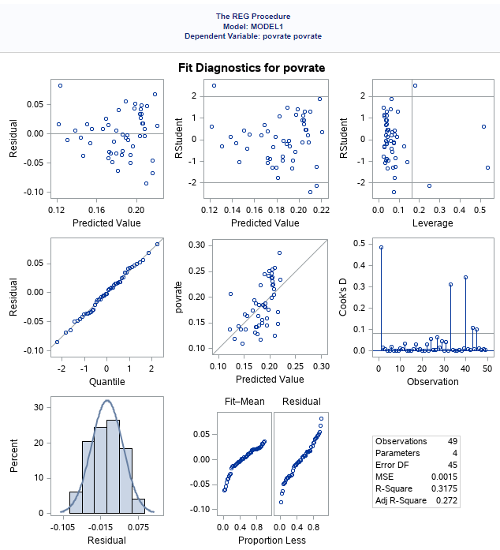

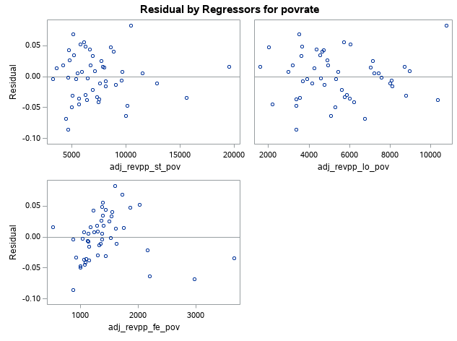

Note. Screenshot from SAS.

Observing the center panel – predicted model poverty rate – the markers are loosely aligned with the diagonal line. Most of the plots are above or below the diagonal line. This indicates the model does not fit the data. It appears that the poverty rate does not predict Adjusted Revenue Per Person on any level of government funding source.

Figure 4. Fit Diagnostics Adjusted Revenue Per Person - Poverty

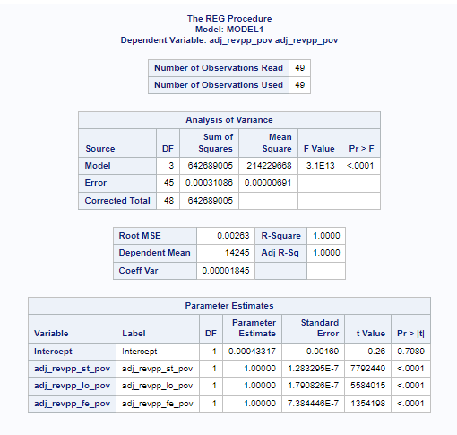

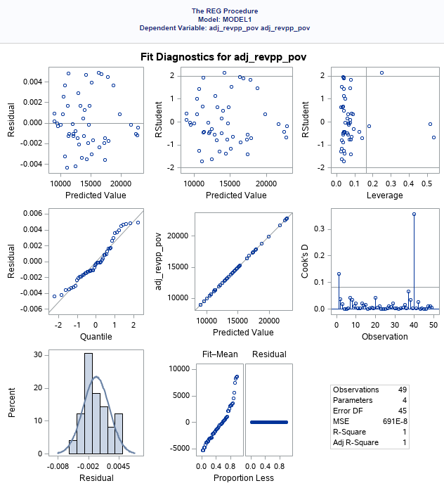

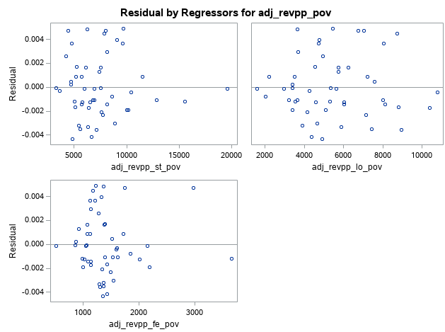

Note. SAS screenshot.

I used prog reg to model Adjusted Revenue Per Person - Poverty to Adjusted Revenue - Poverty for State, Local, and Federal funding. Observing the center panel –Adjusted Revenue Per Person Poverty – the markers are perfectly aligned with the diagonal line. This indicates the model fits the data. It appears that Adjusted Revenue Per Person Poverty predicts Adjusted Revenue Per Person Poverty on all government funding sources.

Figure 5. Fit Diagnostics Adjusted Revenue Per Person - Nonpoverty

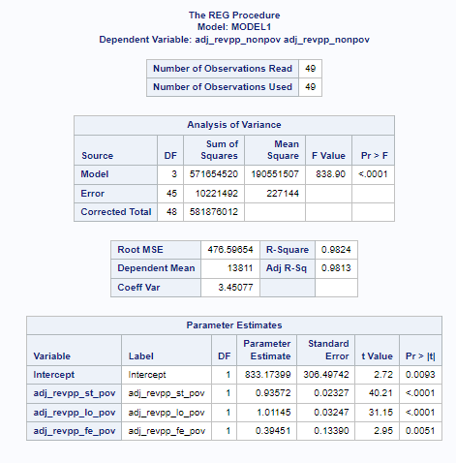

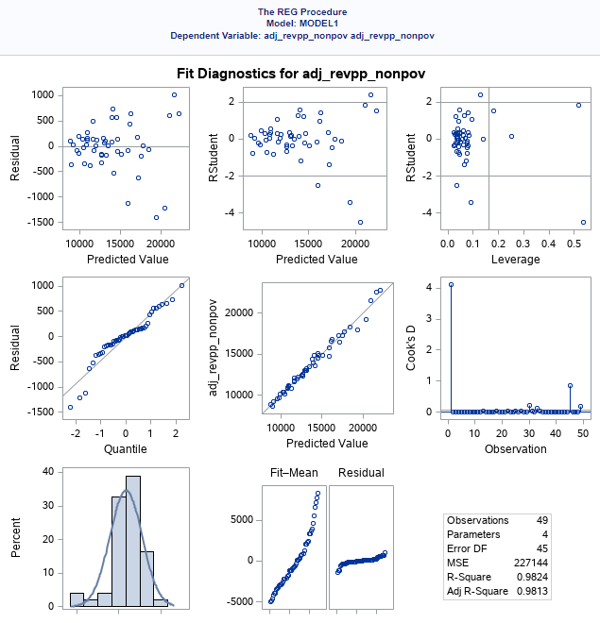

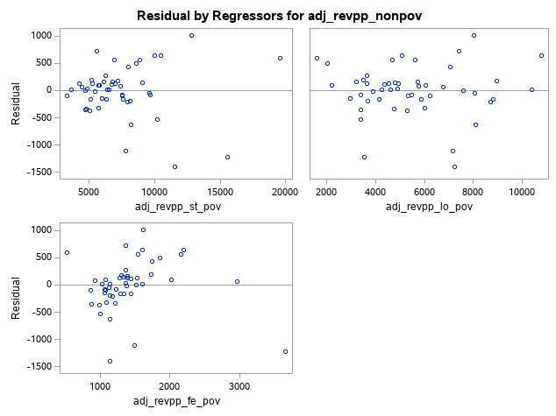

Note. SAS Screenshot.

I used prog reg to model Adjusted Revenue Per Person - Nonpoverty to Adjusted Revenue - Nonpoverty for State, Local, and Federal funding. Observing the center panel –Adjusted Revenue Per Person Nonpoverty – the markers are closely aligned with the diagonal line. This indicates the model fits the data. Comparing the data fit between poverty and nonpoverty, the poverty model fit is greater than the nonpoverty model. It appears that Adjusted Revenue Per Person predicts Adjusted Revenue Per Person on all government funding sources.

Conclusion

Using SAS functions, I was able to answer all the business questions posed. The mean funding levels for poverty and nonpoverty schools are different. The mean funding level at poverty schools is higher than nonpoverty schools at the state and federal levels. The funding level for nonpoverty schools is higher at the local level. This is reflective of the disparity in school funding at the local level. I modeled the poverty rate and adjusted revenue per person at all government levels. There was no correlation between the variables. There is a significant correlation between adjusted revenue per person poverty and funding at state, local, and federal government levels. There was a correlation between adjusted revenue per person nonpoverty and funding at state, local, and federal government levels but not the same level.

References

Baker, B.D. (2017). How Money Matters for Schools. Retrieved from https://learningpolicyinstitute.org/product/how-money-matters-report

# **Learning Policy Institute (2018).** Research Shows That When It Comes to Student Achievement, Money Matters. Retrieved from https://learningpolicyinstitute.org/press-release/research- shows-student-achievement-money-matters

Sharda, R., Delen, D., & Turban, E. (2017). Business Intelligence, Analytics, and Data Science (4th Edition). Pearson Education (US). https://mbsdirect.vitalsource.com/books/9780134635248

Woodward, A.C.E.W. A. (2015). SAS Essentials: A Guide to Mastering SAS (2nd Edition). Wiley Global Research (STMS). https://mbsdirect.vitalsource.com/books/9781119042198